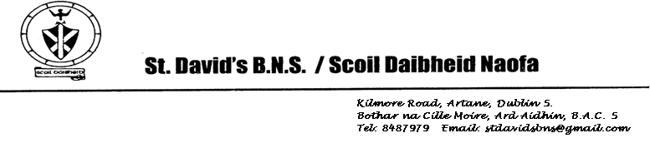

Board of Management Meeting 30th September 2024

Agreed report

* We are delighted to report that we received official notification from the Department of Education that our application to change status, and become a co-educational school from September 2025, has been approved. Applications for September 2025 will be accepted between 1st October 2024 and 31st January 2025.
* Our Admissions Policy was approved at the Board meeting on 30th September 2024.
* We received a letter from the Department of Education on 26th September 2024 confirming that they are now in a position to approve our SEN Base project to proceed to construction. It is hoped to have builders on site in the coming weeks, and you will be given an update when we have more information.
* Our Child Safeguarding Statement Annual Review was carried out at the Board meeting on 30th September 2024.
* The Annual review of our Anti-Bullying policy was carried out at the Board meeting on 30th September 2024.