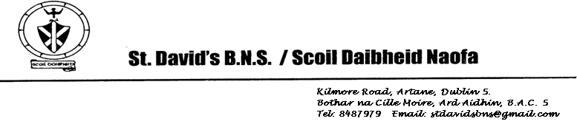

Board of Management Meeting 17/02/2025

Report

* Building Update: A meeting of the Design Team was held on 7th February. The project is on schedule and the physical structure is starting to take place now that the block work has started. The ground workers are currently working on the car park extension. Once again, thank you for your support in helping ensure the safety of pupils, parents and staff at drop-off and collection times.
* We are at the planning stage of our school show which is due to take place towards the end of June. The show committee is busy preparing for this and will keep you posted over the coming months. Every boy will get the opportunity to perform on stage with their class and it will be a very fitting way to sign off on St David’s as an all-boys school before welcoming boys next September.
* Following surveys conducted over the last few months we have decided on a uniform for next year. The incoming Junior Infants will only have a tracksuit. It will be the same colours as our current tracksuit, but the top will have a quarter zip. The rest of the school will continue to wear a mix of our current uniform and tracksuit, but this will be phased out and all pupils will eventually wear the new school tracksuit.
* All pupils will finish at 12 o’clock on Friday 4th April to facilitate staff training on the new Bí Cineálta procedures that all schools must implement from September 2025.