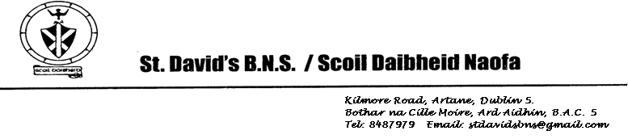

Board of Management Meeting 7th April 2025

Agreed Report

* Building Update: The SEN Base extension work is on schedule. The builders are currently working on the roof and ground works. Thanks to pupils, parents and staff for their co-operation at drop-off and collection times. This has been really important for ensuring the health and safety of everyone at these times.
* Toilet Upgrade: We have an application with the Department for toilet upgrade work to make them suitable for both boys and girls. It is planned that this work will be completed over the summer holidays.
* Summer Programme: Due to the summer work on the toilets, we will only be able to facilitate the summer programme for our ASD classes this year.
* Our school calendar for 2025/2026 has been approved. A copy will be posted on the website but the main dates to remember are:
* Return to school on Thursday 28th August
* Finish school on Friday 26th June
* Closed on 16th March
* Closed on 1st May
* Closed on 29th May & 2nd June